业务要求migo产生批次后 再进行该凭证得批次更新 ，难度很大

前台操作时migo收获操作

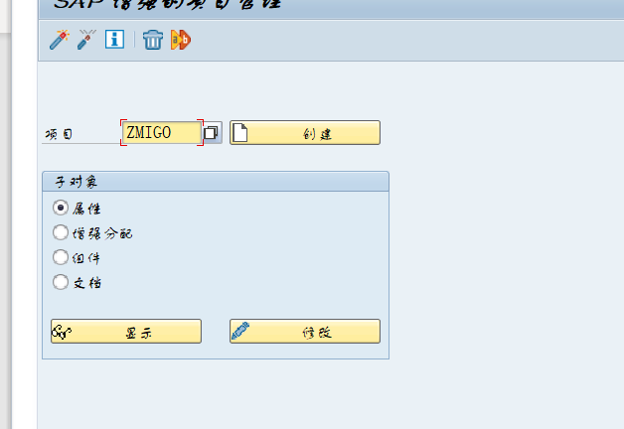

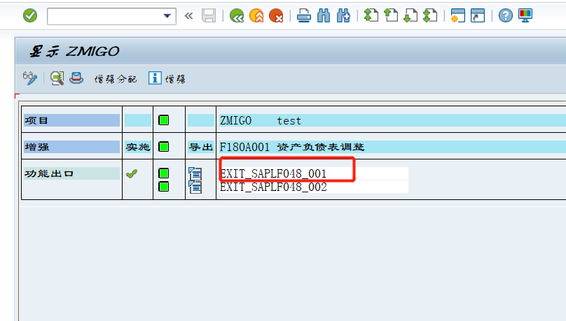

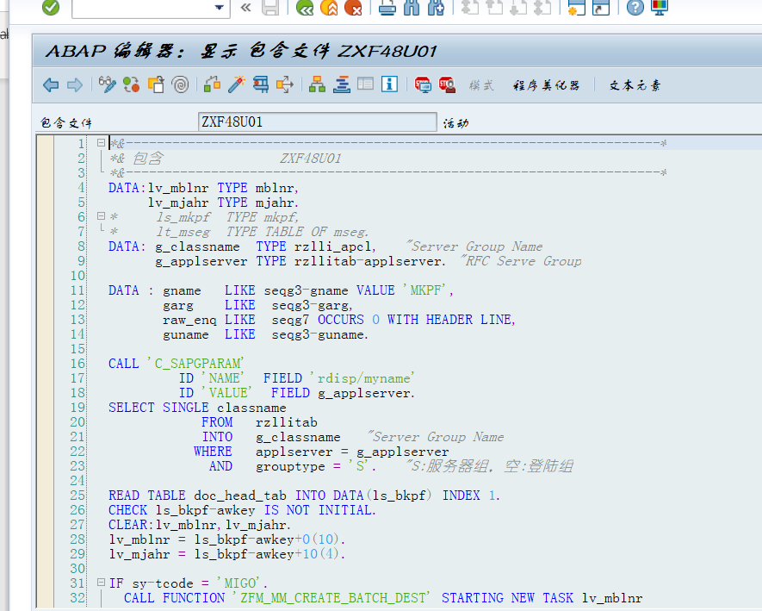

DATA:lv_mblnr TYPE mblnr,  
     lv_mjahr TYPE mjahr.  
*     ls_mkpf  TYPE mkpf,  
*     lt_mseg  TYPE TABLE OF mseg.  
DATA: g_classname  TYPE rzlli_apcl,   "Server Group Name  
      g_applserver TYPE rzllitab-applserver. "RFC Serve Group  
  
DATA : gname   LIKE seqg3-gname VALUE 'MKPF',  
       garg    LIKE  seqg3-garg,  
       raw_enq LIKE  seqg7 OCCURS 0 WITH HEADER LINE,  
       guname  LIKE  seqg3-guname.  
  
CALL 'C_SAPGPARAM'  
         ID 'NAME'  FIELD 'rdisp/myname'  
         ID 'VALUE'  FIELD g_applserver.  
SELECT SINGLE classname  
            FROM   rzllitab  
            INTO   g_classname   "Server Group Name  
           WHERE   applserver = g_applserver  
             AND   grouptype = 'S'.   "S:服务器组，空:登陆组  
  
READ TABLE doc_head_tab INTO DATA(ls_bkpf) INDEX 1.  
CHECK ls_bkpf-awkey IS NOT INITIAL.  
CLEAR:lv_mblnr,lv_mjahr.  
lv_mblnr = ls_bkpf-awkey+0(10).  
lv_mjahr = ls_bkpf-awkey+10(4).  
  
IF sy-tcode = 'MIGO'.  
  CALL FUNCTION 'ZFM_MM_CREATE_BATCH_DEST' STARTING NEW TASK lv_mblnr  
    DESTINATION IN GROUP g_classname  
    PERFORMING frm_batch_upload ON END OF TASK  
    EXPORTING  
      iv_mblnr = lv_mblnr  
      iv_mjahr = lv_mjahr.  
ENDIF.

FORM frm_batch_upload USING lv_mblnr.  
  RECEIVE RESULTS FROM FUNCTION 'ZFM_MM_CREATE_BATCH_DEST'.  
ENDFORM.

Rfc内容

FUNCTION zfm_mm_create_batch_dest.  
*"----------------------------------------------------------------------  
*"*"本地接口：  
*"  IMPORTING  
*"     VALUE(IV_MBLNR) TYPE  MBLNR OPTIONAL  
*"     VALUE(IV_MJAHR) TYPE  MJAHR OPTIONAL  
*"----------------------------------------------------------------------  
  DATA:iv_matnr  TYPE matnr,  
       iv_werks  TYPE werks_d,  
       iv_charg  TYPE charg_d,  
       e_objek   TYPE cuobn,  
       e_obtab   TYPE tabelle,  
       e_klart   TYPE klassenart,  
       e_class   TYPE klasse_d,  
       lt_num    TYPE TABLE OF bapi1003_alloc_values_num,  
       lt_char   TYPE TABLE OF bapi1003_alloc_values_char,  
       lt_curr   TYPE TABLE OF bapi1003_alloc_values_curr,  
       it_mseg   TYPE TABLE OF mseg,  
       is_mkpf   TYPE mkpf,  
       lt_return TYPE TABLE OF bapiret2.  
  
  
  CLEAR:is_mkpf,it_mseg[].  
  DO 10 TIMES.  
    SELECT SINGLE * INTO CORRESPONDING FIELDS OF is_mkpf FROM mkpf WHERE mblnr = iv_mblnr AND mjahr = iv_mjahr.  
    IF sy-subrc = 0.  
      EXIT.  
    ELSE.  
      WAIT UP TO 1 SECONDS.  
    ENDIF.  
  ENDDO.  
  
  IF is_mkpf IS  INITIAL.  
    EXIT.  
  ENDIF.  
  
  SELECT * INTO CORRESPONDING FIELDS OF TABLE it_mseg FROM mseg WHERE mblnr = iv_mblnr AND mjahr = iv_mjahr.  
  
*       ls_catt   TYPE bapibatchatt.  
  "产地 生产厂家编码 生产产家  
  SELECT FROM ekpo AS a  
  INNER JOIN ztcqm002 AS b  
  ON a~werks = b~werks AND  
     a~matnr = b~matnr AND  
     a~idnlf = b~zid  
  FIELDS  
  a~ebeln,a~ebelp,a~matnr,a~idnlf,  
  b~zid,b~zscsmc,b~zchandi  
  FOR ALL ENTRIES IN @it_mseg[]  
  WHERE ebeln = @it_mseg-ebeln  
    AND ebelp = @it_mseg-ebelp  
    AND zdel = ''  
   INTO TABLE @DATA(lt_ekpo).  
  SORT lt_ekpo BY ebeln ebelp matnr.  
  DELETE ADJACENT DUPLICATES FROM lt_ekpo COMPARING ebeln ebelp matnr.  
* 上市许可持有人：证书类型Z032  
* 第二类医疗器械经营备案凭证：证书类型Z015  
* 医疗器械经营许可证：证书类型Z017  
  SELECT FROM ztgsp_lic_mas AS a  
    INNER JOIN t001k AS b  
    ON a~bukrs = b~bukrs  
    INNER JOIN ztgsp_bukrs AS c  
    ON a~bukrs = c~bukrs  
    FIELDS  
    a~zzlicid,b~bwkey AS werks,a~bukrs,a~matnr,a~zzholder,a~zzlictyp,a~zzlicno  
    FOR ALL ENTRIES IN @it_mseg  
    WHERE matnr = @it_mseg-matnr  
      AND zzlictyp IN ('Z032','Z015','Z017')  
      AND zzvalto > @sy-datum  
      AND b~bwkey = @it_mseg-werks  
     INTO TABLE @DATA(lt_lic_mas).  
  SORT lt_lic_mas BY werks matnr zzlictyp.  
  DELETE ADJACENT DUPLICATES FROM lt_lic_mas COMPARING werks matnr zzlictyp.  
*注册证/备案号取数逻辑：  
  SELECT FROM ztmm_master_bas  
    FIELDS  
    matnr,  
    zzcba  
    FOR ALL ENTRIES IN @it_mseg  
    WHERE matnr = @it_mseg-matnr  
    INTO TABLE @DATA(lt_master_bas).  
  SORT lt_master_bas BY matnr.  
  LOOP AT it_mseg ASSIGNING FIELD-SYMBOL(<fs_mseg>) WHERE bwart = '101'  
                                                      AND  kzbew = 'B' AND charg IS NOT INITIAL.  
    CLEAR:  
       iv_matnr,  
       iv_werks,  
       iv_charg,  
       e_objek,  
       e_obtab,  
       e_klart,  
       e_class,  
*       ls_catt,  
       lt_num[],  
       lt_char[],  
       lt_curr[],  
       lt_return[].  
    iv_matnr = <fs_mseg>-matnr.  
    iv_werks = <fs_mseg>-werks.  
    iv_charg = <fs_mseg>-charg.  
    CALL FUNCTION 'VB_BATCH_2_CLASS_OBJECT'  
      EXPORTING  
        i_matnr = iv_matnr  
        i_charg = iv_charg  
        i_werks = iv_werks  
      IMPORTING  
        e_objek = e_objek  
        e_obtab = e_obtab  
        e_klart = e_klart  
        e_class = e_class.  
    CALL FUNCTION 'BAPI_OBJCL_GETDETAIL'  
      EXPORTING  
*       OBJECTKEY       =  
        objecttable     = e_obtab  
        classnum        = e_class  
        classtype       = e_klart  
*       KEYDATE         = SY-DATUM  
*       UNVALUATED_CHARS       = ' '  
*       LANGUAGE        = SY-LANGU  
        objectkey_long  = e_objek  
* IMPORTING  
*       STATUS          =  
*       STANDARDCLASS   =  
      TABLES  
        allocvaluesnum  = lt_num  
        allocvalueschar = lt_char  
        allocvaluescurr = lt_curr  
        return          = lt_return.  
    READ TABLE lt_ekpo ASSIGNING FIELD-SYMBOL(<fs_ekpo>) WITH KEY ebeln = <fs_mseg>-ebeln  
                                                                  ebelp = <fs_mseg>-ebelp  
                                                                  matnr = <fs_mseg>-matnr  
                                                                  BINARY SEARCH.  
    IF sy-subrc = 0.  
      IF e_class = 'Z_BATCH01'.  
        " 生产厂家编号  
        IF <fs_ekpo>-zid IS NOT INITIAL.  
          READ TABLE lt_char ASSIGNING FIELD-SYMBOL(<fs_char>) WITH KEY charact = 'Z_DATA21'.  
          IF sy-subrc = 0.  
            <fs_char>-value_char     = <fs_ekpo>-zid.  
            <fs_char>-value_neutral  = <fs_ekpo>-zid.  
          ELSE.  
            APPEND INITIAL LINE TO lt_char ASSIGNING <fs_char>.  
            <fs_char>-charact        = 'Z_DATA21'.  
            <fs_char>-value_char     = <fs_ekpo>-zid.  
            <fs_char>-value_neutral  = <fs_ekpo>-zid.  
          ENDIF.  
        ENDIF.  
        "生产厂家  
        IF <fs_ekpo>-zscsmc IS NOT INITIAL.  
          IF <fs_char> IS ASSIGNED.  
            UNASSIGN <fs_char>.  
          ENDIF.  
          READ TABLE lt_char ASSIGNING <fs_char> WITH KEY charact = 'Z_DATA05'.  
          IF sy-subrc = 0.  
            <fs_char>-value_char     = <fs_ekpo>-zscsmc.  
            <fs_char>-value_neutral  = <fs_ekpo>-zscsmc.  
          ELSE.  
            APPEND INITIAL LINE TO lt_char ASSIGNING <fs_char>.  
            <fs_char>-charact        = 'Z_DATA05'.  
            <fs_char>-value_char     = <fs_ekpo>-zscsmc.  
            <fs_char>-value_neutral  = <fs_ekpo>-zscsmc.  
          ENDIF.  
        ENDIF.  
        "产地  
        IF <fs_ekpo>-zchandi IS NOT INITIAL.  
          IF <fs_char> IS ASSIGNED.  
            UNASSIGN <fs_char>.  
          ENDIF.  
          READ TABLE lt_char ASSIGNING <fs_char> WITH KEY charact = 'Z_DATA23'.  
          IF sy-subrc = 0.  
            <fs_char>-value_char     = <fs_ekpo>-zchandi.  
            <fs_char>-value_neutral  = <fs_ekpo>-zchandi.  
          ELSE.  
            APPEND INITIAL LINE TO lt_char ASSIGNING <fs_char>.  
            <fs_char>-charact        = 'Z_DATA23'.  
            <fs_char>-value_char     = <fs_ekpo>-zchandi.  
            <fs_char>-value_neutral  = <fs_ekpo>-zchandi.  
          ENDIF.  
        ENDIF.  
      ENDIF.  
    ENDIF.  
    IF e_class = 'Z_BATCH03'.  
      READ TABLE lt_lic_mas ASSIGNING FIELD-SYMBOL(<fs_lic_mas>) WITH KEY werks = <fs_mseg>-werks"4.2.6  上市许可持有人  
                                                                          matnr = <fs_mseg>-matnr  
                                                                          zzlictyp = 'Z032'  
                                                                          BINARY SEARCH.  
      IF sy-subrc = 0.  
        READ TABLE lt_char ASSIGNING <fs_char> WITH KEY charact = 'Z_DATA43'.  
        IF sy-subrc = 0.  
          <fs_char>-value_char     = <fs_lic_mas>-zzlicno.  
          <fs_char>-value_neutral  = <fs_lic_mas>-zzlicno.  
        ELSE.  
          APPEND INITIAL LINE TO lt_char ASSIGNING <fs_char>.  
          <fs_char>-charact        = 'Z_DATA43'.  
          <fs_char>-value_char     = <fs_lic_mas>-zzlicno.  
          <fs_char>-value_neutral  = <fs_lic_mas>-zzlicno.  
        ENDIF.  
      ENDIF.  
      READ TABLE lt_lic_mas ASSIGNING <fs_lic_mas> WITH KEY werks    = <fs_mseg>-werks  
                                                            matnr    = <fs_mseg>-matnr  
                                                            zzlictyp = 'Z015'  
                                                            BINARY SEARCH.  
      IF sy-subrc = 0.  
        READ TABLE lt_char ASSIGNING <fs_char> WITH KEY charact = 'Z_DATA45'."4.2.8  医疗器械经营许可证  
        IF sy-subrc = 0.  
          <fs_char>-value_char     = <fs_lic_mas>-zzlicno.  
          <fs_char>-value_neutral  = <fs_lic_mas>-zzlicno.  
        ELSE.  
          APPEND INITIAL LINE TO lt_char ASSIGNING <fs_char>.  
          <fs_char>-charact        = 'Z_DATA45'.  
          <fs_char>-value_char     = <fs_lic_mas>-zzlicno.  
          <fs_char>-value_neutral  = <fs_lic_mas>-zzlicno.  
        ENDIF.  
      ENDIF.  
      READ TABLE lt_lic_mas ASSIGNING <fs_lic_mas> WITH KEY werks    = <fs_mseg>-werks  
                                                            matnr    = <fs_mseg>-matnr  
                                                            zzlictyp = 'Z017'  
                                                            BINARY SEARCH.  
      IF sy-subrc = 0.  
        READ TABLE lt_char ASSIGNING <fs_char> WITH KEY charact = 'Z_DATA46'."4.2.8  医疗器械经营许可证  
        IF sy-subrc = 0.  
          <fs_char>-value_char     = <fs_lic_mas>-zzlicno.  
          <fs_char>-value_neutral  = <fs_lic_mas>-zzlicno.  
        ELSE.  
          APPEND INITIAL LINE TO lt_char ASSIGNING <fs_char>.  
          <fs_char>-charact        = 'Z_DATA46'.  
          <fs_char>-value_char     = <fs_lic_mas>-zzlicno.  
          <fs_char>-value_neutral  = <fs_lic_mas>-zzlicno.  
        ENDIF.  
      ENDIF.  
      READ TABLE lt_master_bas ASSIGNING FIELD-SYMBOL(<fs_master_bas>) WITH KEY matnr = <fs_mseg>-matnr BINARY SEARCH.  
      IF sy-subrc = 0.  
        READ TABLE lt_char ASSIGNING <fs_char> WITH KEY charact = 'Z_DATA44'.  
        IF sy-subrc = 0.  
          <fs_char>-value_char     = <fs_master_bas>-zzcba.  
          <fs_char>-value_neutral  = <fs_master_bas>-zzcba.  
        ELSE.  
          APPEND INITIAL LINE TO lt_char ASSIGNING <fs_char>.  
          <fs_char>-charact        = 'Z_DATA44'.  
          <fs_char>-value_char     = <fs_master_bas>-zzcba.  
          <fs_char>-value_neutral  = <fs_master_bas>-zzcba.  
        ENDIF.  
      ENDIF.  
    ENDIF.  
    CALL FUNCTION 'BAPI_OBJCL_CHANGE' "对特性值进行一次更改  
      EXPORTING  
*       OBJECTKEY          = E_OBJEK  
        objecttable        = e_obtab  
        classnum           = e_class  
        classtype          = e_klart  
        objectkey_long     = e_objek  
*      IMPORTING  
*       CLASSIF_STATUS     = V_STATUS  
      TABLES  
        allocvaluesnumnew  = lt_num  
        allocvaluescharnew = lt_char  
        allocvaluescurrnew = lt_curr  
        return             = lt_return  
      EXCEPTIONS  
        OTHERS             = 01.  
  
    DATA:lv_check TYPE c.  
    CLEAR:lv_check.  
    LOOP AT lt_return ASSIGNING FIELD-SYMBOL(<lfs_rettab>) WHERE type CA 'AEX'.  
      ROLLBACK WORK.  
      lv_check = 'X'.  
      EXIT.  
    ENDLOOP.  
  
    IF lv_check = ''.  
      COMMIT WORK .  
    ENDIF.  
  ENDLOOP.  
ENDFUNCTION.